# DISKS

~VHDs attached to VMs (virtual hard drive)

* Standard
  + Fixed in IOPs and throughput (input/output per sec)
    - Tied to the tier of VM
  + Backups, non-prod stuff (latency does not matter that much)
* Premium
  + SSD only
  + Prod stuff
  + Not tied to VM’s tier, can be added separately to VM

**If you are unable to connect from your computer to a Windows VM by RDP, what is the first thing you should check?**

Check port 3389 is open on Network Sec Group

**What is the default VM size that Azure wants to use when you create a VM?**

Standard DS1

# Azure Disks

* Managed
  + Recommended
* Unmanaged
  + Scalability limits

# VM Disk Topology

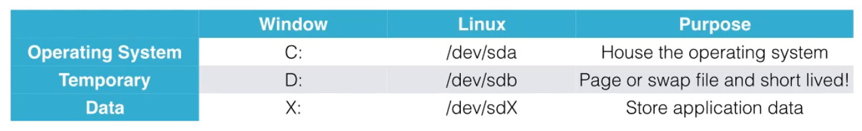

Temporary disk: stuff can be stored on it, but only SHORT LIVED data

# Common Disk Admin Ops:

* Create/provision
* Attach VHD to VM
* Prepare disk for OS
* Create snapshot
  + Full, readonly copy of single vhd
  + Not really great for recovery stuff**: use Azure Recovery Services for that**
  + Can be created for:
    - **OS disk:** copy snapshot into new disk, spin up a VM from that copy vhd
    - **Data disks:** copy to new disk and mount it (could be the same VM or new VM)
* Resize
* Remove

# Attaching disk (can be done hot)

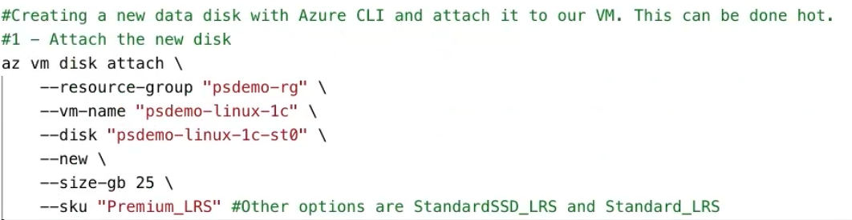

…then SSH into VM:

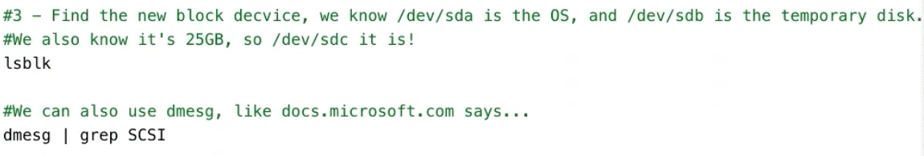





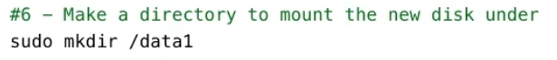



# Resizing disk (VM has to be stopped~deallocated)

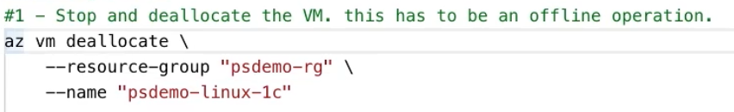

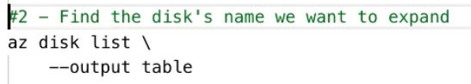

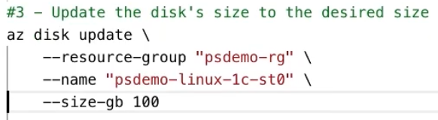

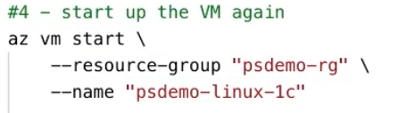

# Detach disk (can be done online/hot)

First unmount the disk in the OS

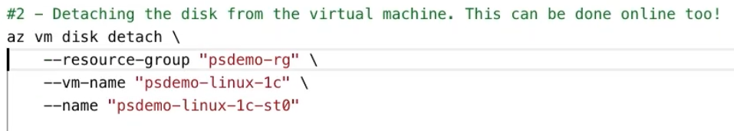

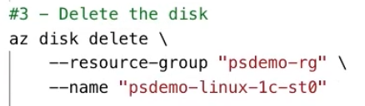

# Snapshotting OS Disk



